PROJECT REPORT

Gemini Historical Artifact Description System
Date | 17 February 2026
Team ID | LTVIP2026TMIDS78778
Project Name | Gemini Historical Artifact Description

1. INTRODUCTION

1.1 Project Overview
The Gemini Historical Artifact Description System is an AI-powered web application designed to generate structured and detailed descriptions of historical artifacts using text input and image upload. The system leverages generative AI to provide accurate, engaging, and well-formatted content for students, historians, museums, and researchers.

1.2 Purpose
The purpose of this project is to simplify the process of creating historical artifact descriptions by automating research and content generation using Artificial Intelligence. It reduces manual effort, improves accuracy, and enhances accessibility to historical knowledge.

2. IDEATION PHASE

2.1 Problem Statement
Students, educators, and museum professionals face difficulty in preparing accurate and structured descriptions of historical artifacts due to limited resources, time constraints, and lack of expertise.

2.2 Empathy Map Canvas
User Says:
- “I need quick and accurate historical information.”
- “Research takes too much time.”
User Thinks:
- “Is this information reliable?”
- “How can I make this more engaging?”
User Does:
- Searches online sources
- Reads multiple websites
- Compiles information manually
User Feels:
- Frustrated
- Time-pressured
- Unsure about accuracy

Empathy Map Diagram
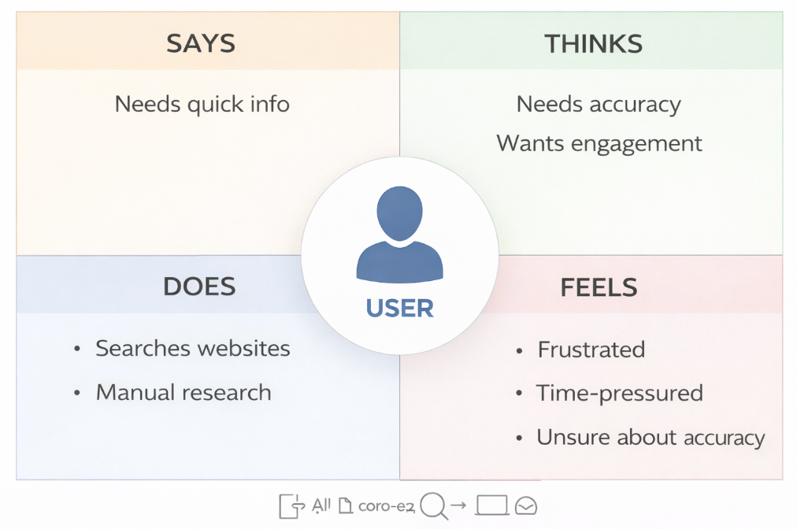

2.3 Brainstorming
Ideas considered:
- Manual artifact database
- Wikipedia-style knowledge base
- AI chatbot
- Image recognition + AI description generator
Final Idea Selected:
AI-powered automated artifact description system combining text and image input.

3. REQUIREMENT ANALYSIS

3.1 Customer Journey Map
Step 1: User opens website
Step 2: Enters artifact name / uploads image
Step 3: Selects word count
Step 4: Clicks Generate
Step 5: Receives structured artifact description
Step 6: Downloads or copies content

Customer Journey Diagram
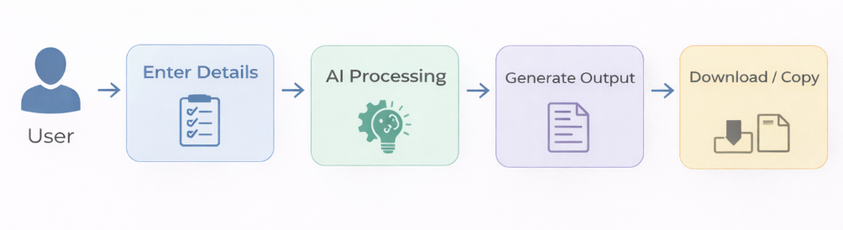3.2 Solution Requirement

Functional Requirements:
- Accept artifact name input
- Accept image upload
- Word count selection
- AI-generated structured output
- Regenerate option

Non-Functional Requirements:
- Response time under 3 seconds
- Secure API handling
- Scalable cloud deployment
- User-friendly interface

3.3 Data Flow Diagram

Level 0 DFD

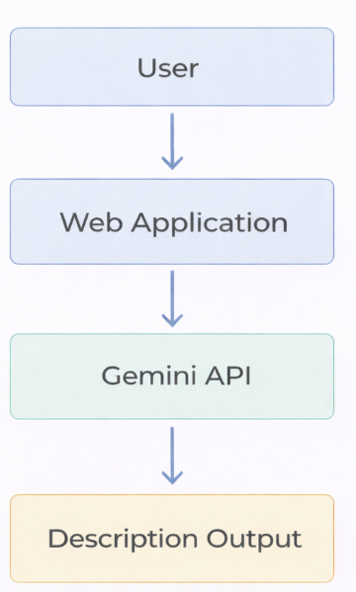

3.4 Technology Stack
Frontend: HTML, CSS, JavaScript
Backend: Python
AI Model: Google Gemini API
Database: (Optional) Firebase / Local Storage
Deployment: Cloud Platform

4. PROJECT DESIGN

4.1 Problem Solution Fit
The system directly addresses user pain points by reducing research time and providing reliable structured descriptions instantly.

4.2 Proposed Solution
An AI-based web platform that generates structured historical artifact descriptions based on user input and image analysis.

4.3 Solution Architecture
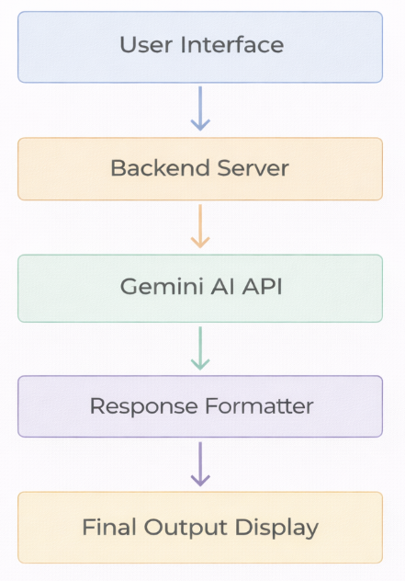
5. PROJECT PLANNING & SCHEDULING

5.1 Project Planning
Phase 1 – Ideation & Research
Phase 2 – Requirement Analysis
Phase 3 – Development
Phase 4 – Testing
Phase 5 – Deployment
Phase 6 – Documentation
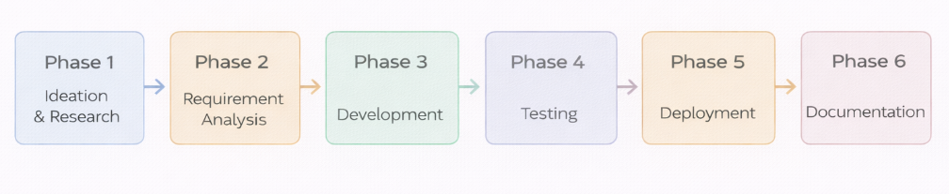

6. FUNCTIONAL AND PERFORMANCE TESTING

6.1 Performance Testing
- Response time: 2–3 seconds
- API load handling: Stable under concurrent requests
- Image upload processing: Smooth
- No system crashes during stress test

7. RESULTS

7.1 Output Screenshots
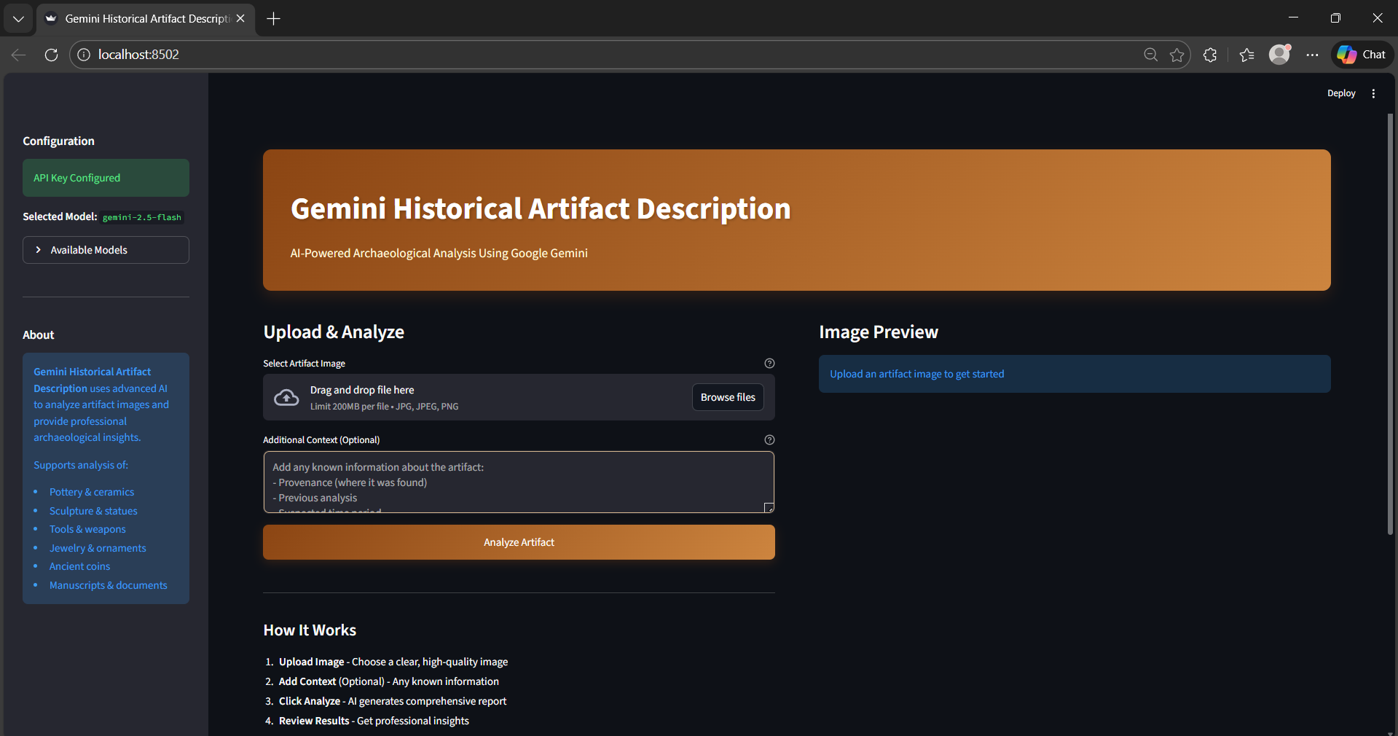

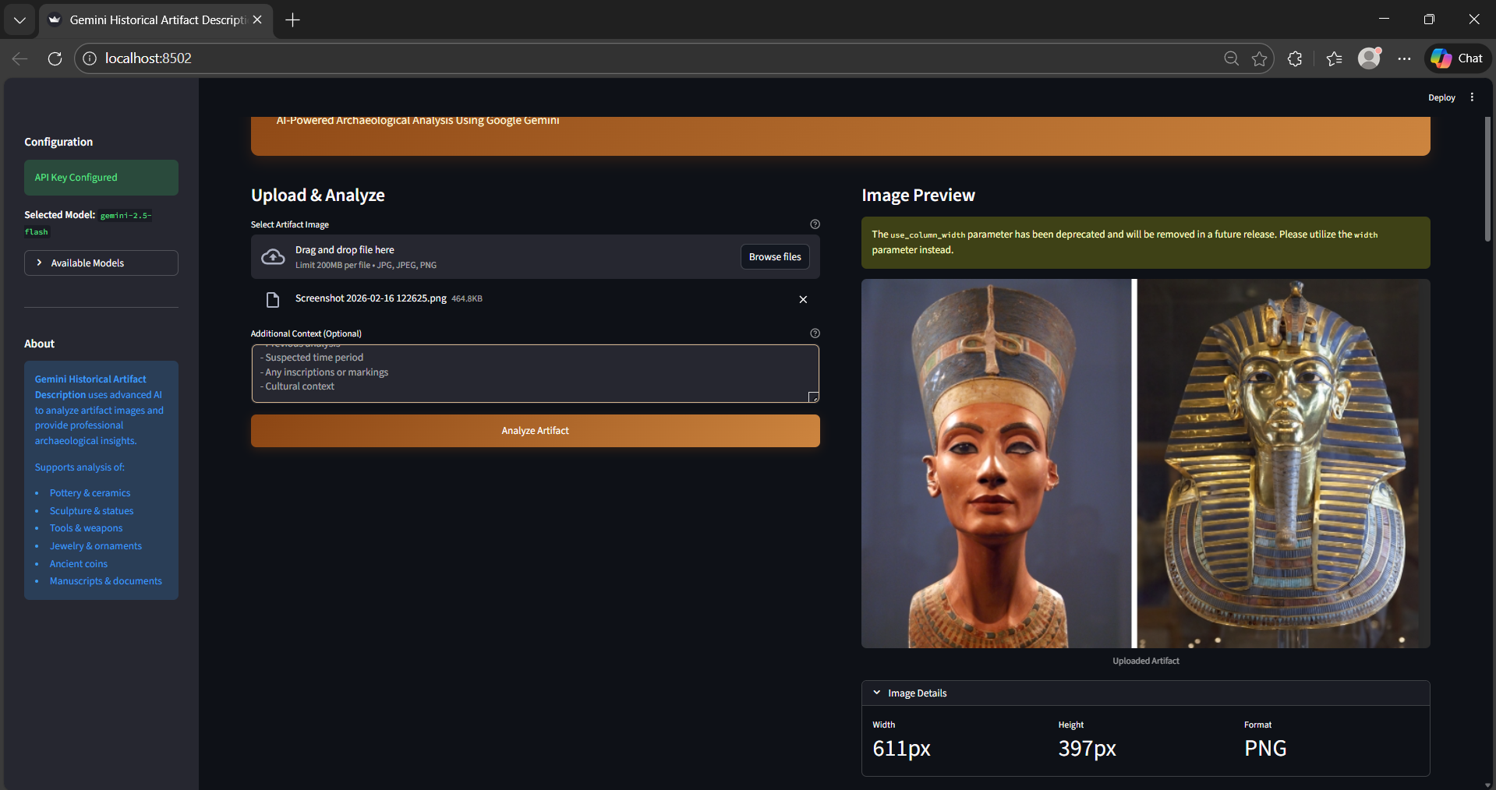
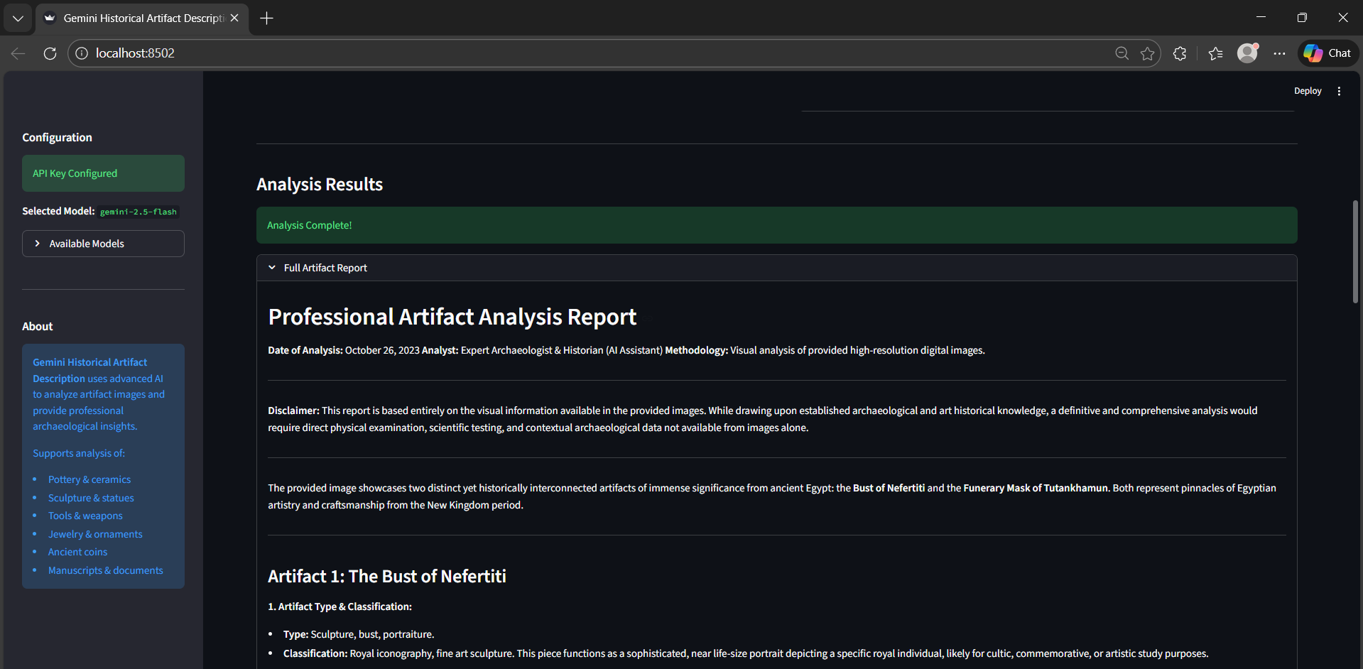
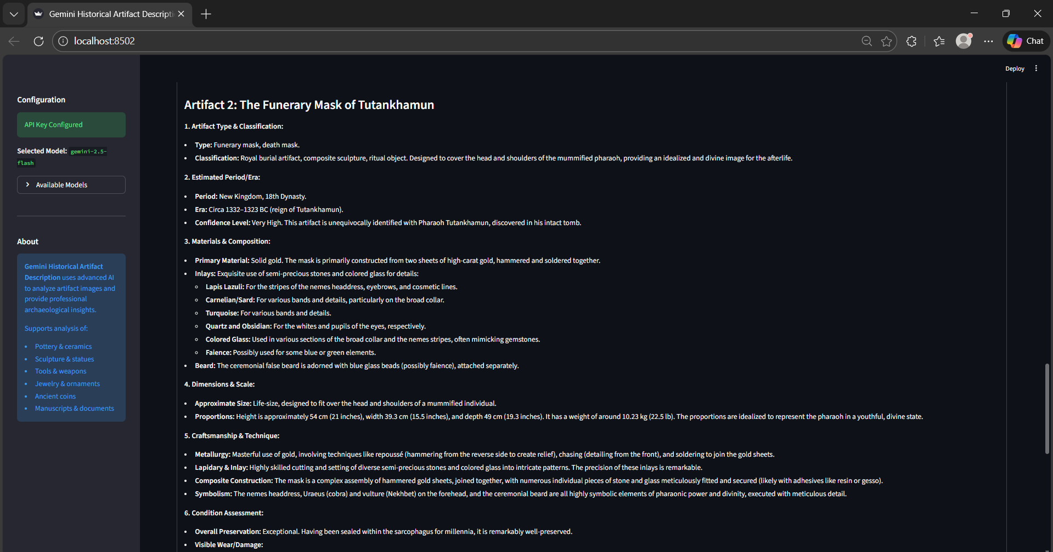
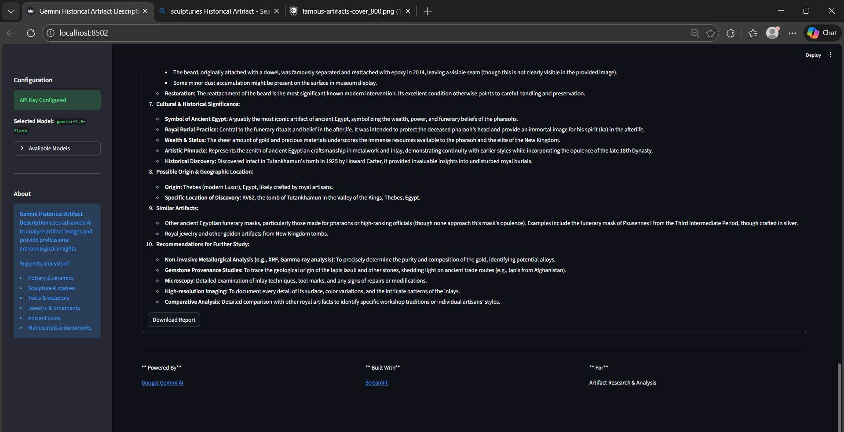
The system successfully generates structured artifact descriptions including:
- Origin
- Historical Period
- Significance
- Interesting Facts

8. ADVANTAGES & DISADVANTAGES

Advantages:
- Saves time
- Improves accuracy
- Easy to use
- Scalable
- Supports image input

Disadvantages:
- Requires internet connection
- Dependent on API service
- AI output may require minor review

9. CONCLUSION
The Gemini Historical Artifact Description System successfully demonstrates the practical integration of generative AI into educational and research workflows. The project effectively achieves its primary objective of automating artifact description generation while ensuring accuracy, consistency, and contextual relevance. By leveraging AI capabilities, the system significantly reduces manual effort and enhances productivity for researchers, educators, and students.
Furthermore, the architecture ensures scalability and performance optimization, allowing the system to handle multiple requests efficiently without compromising response quality. The modular design also supports future enhancements, such as multilingual support, image-based artifact recognition, and integration with digital museum databases.
The implementation highlights how AI-driven automation can transform traditional documentation processes into intelligent, dynamic, and interactive systems. Overall, the project not only meets its functional requirements but also establishes a strong foundation for future expansion and real-world deployment in academic, cultural heritage, and digital archiving environments.

10. FUTURE SCOPE
- Multi-language support
- Voice input feature
- Artifact database integration
- Mobile application version
- Offline mode with local dataset

11. APPENDIX

Source Code

https://drive.google.com/drive/folders/1Id7AdyN_VeGMlkC9CmwgQjUEHs5yd_H6

Image Links

https://sl.bing.net/jXH2DuOagBE

https://sl.bing.net/bn93Bv35Pau

GitHub
https://github.com/varshitha3114/Gemini-Historical-Artifact-System-
Video Link
https://drive.google.com/file/d/1sox3t_7N4_iU2vX188-fvh5oDuvayRY8/view?usp=sharing

